**Successful deployment**

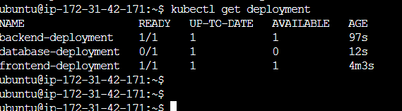

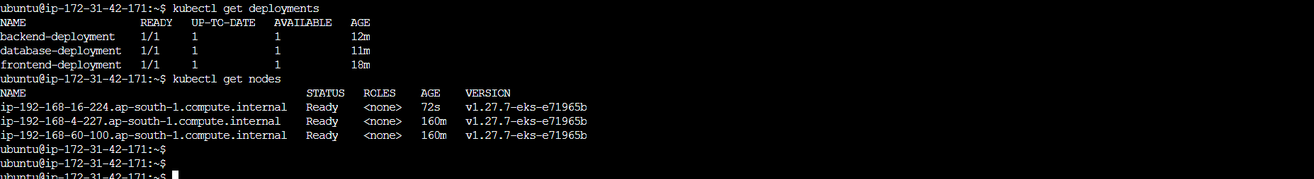

**Rolling deployment**

Modifying the backend deployment

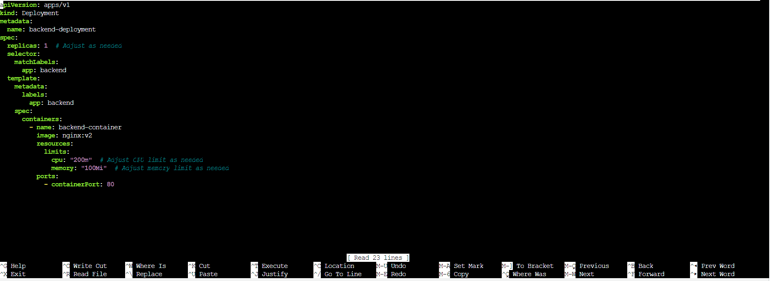

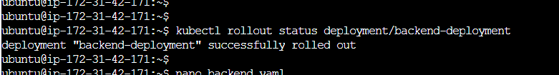

**Ingress configuration**

Ingress file

